http://hopeelementaryschoollibrary.weebly.com/

Capstone Project
Assignment 4
ISTC 601- Library Administration
Chrissy McHugh, Stephanie Richardson, Tracy Richter

Introduction:
Type of school:
- Public
- K-5 Elementary
- 4 classes of each grade level
  - Approximately 25 students per class
  - A total of 600 students
  - At least 3,600 sq feet (6sq feet per student) 6 x 600= 3,600
- Area: Suburban
- Notes:
  - We are using the ground up approach for building a new library.
  - Using Beltsville Academy as a model for space and comparisons.
Starting Model: Beltsville Academy (S. Richardson, personal communication, April 21, 2013).
The following are things about this school library we would like to improve:
- Library office is too small and does not allow for collaborative planning.
- Storage space needs to be increased. Specifically AV is incompatible for modern technology.
- TV studio is more of a holding place for equipment rather than a functional work space for students. Students must produce the morning announcements in the library instead of in the actual TV production room.
  - Due to the fact that students must use the library to produce the announcements in the morning, circulation of materials cannot take place in the time before school.
- Electrical outlets need to be relocated so they are not in the middle of the room. Students need to have access to outlets right at their workstations.
- A reading corner needs to be incorporated in order to encourage reading for pleasure.
- Furniture in the library should be inviting and comfortable. Currently, students sit at wooden tables and hard plastic chairs.
The following existing advantages are ones we would like to incorporate into a new school library:
- The library is centrally located so students have easy access to the library.
- There is an excellent amount of natural light.

Section 1: Samples of Programs
- Marlborough Elementary (Marlborough Elementary, 2012). –

- Removal of tall shelving and replaced them with lower ones to make materials more accessible.
- Shelves on wheels allow for space to be rearranged according to events taking place in the library or group work.
- An independent/ quiet place is located on a cozy carpet for students to work alone.
- Mobile carts housing laptops and IPads are kept in the library for easy use.
- Bulletin boards were located over each section. Bulletin boards displayed various genres and helpful library suggestions.
- Presentation room with SMART Board allows for lessons in a quiet space while library check out can still take place.
- Sofas make the library space homey.
- Book return box allows students to easily return materials.
- Areas where student work is displayed are prominently visible.
- Bright accent walls and colorful carpet make the library a fun place to be.
- West Towson Elementary (Baltimore County Public Schools, n.d.).
- 36 inch free standing shelves are present. These allow teachers to always have a line of vision on students and students to be able to reach materials.
- Large group area allows for collaboration.
- Wireless access cuts down on electronic devices that need to be plugged in.
- TV studio has enough room for production, taping and editing. Counter space is also there for monitors. The space is large enough for small group instruction and handicap accessible.
- A separate work area is available for individual students and is online ready.
- A workroom is where collaboration can take place. Also in this room is where cataloging and process can take place. Professional collections are housed in this room as well.
- Equipment audio-visual room is locked so SLM can control distribution.
- Computer equipment room (servers, etc) is present.

- Baltimore County Public Library – Perry Hall Branch (Baltimore County Public Library, 2013; C. McHugh, personal communication, April 21, 2013).
- A large children’s section allows children to play in groups or independently. Children also have access to the library catalog as well as interactive educational programs. Shelves are low in the picture book section. Sofas and chairs are great places for parents and children to read together.
- There are two small group quiet work rooms. Tutoring or group work can take place in these isolated rooms.
- 6-7 small tables are there for independent work or collaboration.
- Private work stations with computer access are helpful for quiet work.
- Many event posters line the walls and encourage patrons to become involved in the community events.
- Magazine shelving and cozy sofas are located in the young adult section.
- Towson University (Towson University, 2011; S. Richardson & T. Richter, personal communication, April 21, 2013.)
- Closed off small group areas with presentation screens for instruction.
- Signage is clear and directs patrons of where to find materials.
- The facility is handicap accessible.
- There are independent work stations.
- Help desk and circulation desks are centrally located.

Section 2: Floor Plan

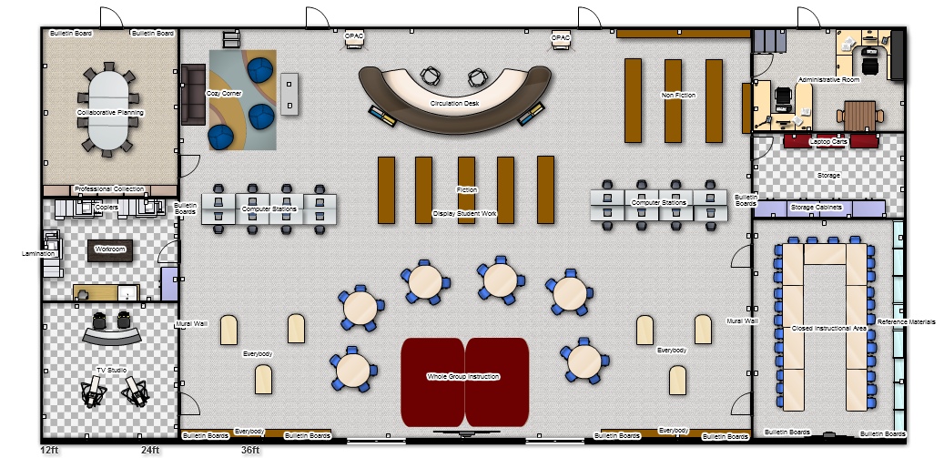

Section 3: Educational Specifications
Area 1: Study and Research Area (Standard 6.01.01) (Maryland State Board of Education, 2000).
In this area there will be:
- Be able to access basic collections.
  - Non-Fiction, Fiction, Everybody books, and magazines.
  - Reference materials will be located in a closed off reference room. Students will have access to these materials unless a class is using the room. In this instance, students may use online databases.
  - Professional Library materials will be located in the closed off Collaborative Planning Room.
  - Two online stations will be available in the large open section of the library. The computers will be on tables with outlets. These tables will have multiple computers on them.
  - The entire library will have online wireless access to allow users to work anywhere in the library.
  - There will be three mobile laptop carts.
    - One cart will stay in the library and be used for class instruction.
    - The other two carts will be housed in the locked Storage room. These can be checked out by teachers for classroom use. The carts will be locked to ensure that materials will not be lost or stolen and so that the librarian can keep track of materials.
    - Each cart will have a teacher computer, projector, wireless router and wireless printer
  - Online stations will have access to the OPAC. Two small computers housed on either side of the circulation desk will also be used as the primacy OPAC for students to check the availability of materials.
Usage | Specification | Picture | Price | Quantity
Freestanding shelves  -For use in the Everybody Section  http://www.demco.com/goto?BLS175541&ALL0000&es=20130421145045935212 | -Green  -Laminate  -42” mobile  -Double sided | 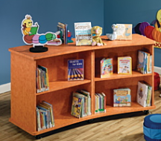 | $1424.99 | 2
Freestanding Shelves  http://www.demco.com/goto?blk00175470&intcmp=BMR_00175470  - For use in the Fiction Section | -Med Oak/Brown  -Ironwood Glacier- Laminate Library Shelving  - 48’’ high  -36” wide  - 24”deep  - Double sided | 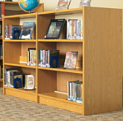 | 699.99 | 10
Wall mounted shelves  http://www.demco.com/goto?blk00175470&intcmp=BMR_00175470  -For use in the Everybody Section and Non-Fiction Section | Med Oak/Brown  -Ironwood Glacier- Laminate Library Shelving  - 48’’ high  -38” wide  - 24”deep  - Single sided | 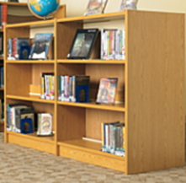 | $394.99 | 8
Magazine rack  http://www.demco.com/goto?BLS173301&ALL0000&es=20130421151728355001  -For use in the Cozy Corner | -Durham – Contur Rotary Literature Rack  -44 pockets  -49” Spinner  -Tan | 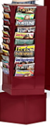 | $379.99 | 1
Two online computer stations with desk mounted outlets  http://www.demco.com/goto?BLS170518&ALL0000&es=20130421154005267211 | -Medium Oak  -Double model  -36-1/4” x 60” x 35 – ¾” | 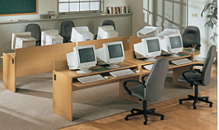 | $489.99 | 8
3 mobile laptop carts  http://www.apple.com/education/labs | -Comes with 20 computers internet ready  -Can hold 30 laptop | 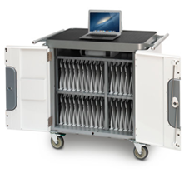 | $25,000 | 3
2 small desks for OPAC stations  http://www.demco.com/goto?BLS174149&ALL0000&es=20130421155800337709 | -Ironwood Glacier End of Range PAC Station  -Elementary height  -Medium Oak color  -36-1/8”x23 -5/8x 18” | 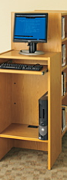 | $369.99 | 2

Area 2: Informal Reading ( Standard 6.01.02) (Maryland State Board of Education, 2000).
In this area there will be:
- A story area with a whole group meeting spot:
  - Bright, colorful carpet will outline the place students will sit.
  - A SMART Board will be located on the wall for interactive storytelling as well as formal teaching.
  - On the walls, there will be a creative and engaging mural featuring popular characters from children’s books.
  - Bulletin boards containing information about story genres or helpful library tips will be near the Everybody section. These will promote literacy and engage students in upcoming events.
- An Informal and independent reading area:
  - This will be located by the circulation desk so staff can oversee student activity.
  - In this area there will be magazines, as well as places for students to read.
  - Sofas carpets and beanbag chairs will be places for independent reading time.
  - A padded bench will allow for students to plug in wireless tools as well as another seating spot.
  - A dozen lap desks will be housed here for use with the mobile laptop station.
Usage | Specification |  | Picture | Price | Quantity
Large group instructional carpet. This carpet should have squares for outlined seating places.  http://www.demco.com/goto?BLS167736&ALL0000&es=20130421155230551641 | -Eric Carle Animal Carpet  -7’8 W x 5’4 D |  | 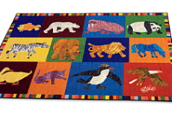 | $289.99 | 2
SMART Board for whole group instruction/ story telling  http://www.touchboards.com/smartboards/SMART_SB885ixe-SMP.html?Source=Google&gclid=CIKu77DS3LYCFaNhMgodERcAjQ | -Projector  -Mount  -Computer connection  -Screen | 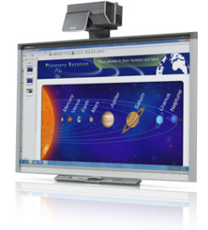 |  | $9499.00 | 1
Magazine rack | See previous section
3 Beanbag chairs  http://www.demco.com/goto?BLS195945&ALL0000&es=20130421161535186951 | -Cuddly Cocoon Giant Floor Pear Cushion  -Large  -23-1/2” H x 31”Diameter  -Green/Light Green | 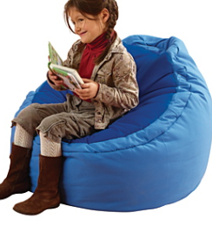 |  | $379.99 | 3
Sofa  http://www.demco.com/goto?BLS167807&ALL0000&es=20130421162059051627 | -Whitney Brothers Modular Reading Nook Couches  -Vinyl Covered Reading Nook  -Book shelves on the opposite sides  -18”x 17 ½” x 24” | 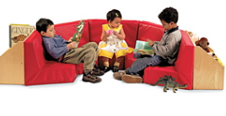 |  | $214.99 | 1
25 Lap desks  http://lapdesk.com/lap-desk/cid-9 | -Student Lap Desk  -Green  -15.38 Width  -12.38 Length | 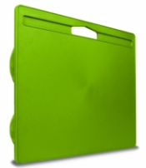 |  | $14.99 | 25
Plush carpeting for students to sit on and read.  http://www.ikea.com/us/en/catalog/products/70203768/ | -High Pile Rug  -Green  - 4’4”x 6’5” |  |  | $49.99 | 2
A padded bench with outlets installed in the sides will create seating and computer access using laptops.  http://www.demco.com/goto?BLS195897&ALL0000&es=20130421160910800846 | -Wood Designs Double Bench  -20”x30”x16” | 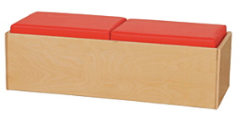 |  | $259.99 | 2

Area 3: Instructional Area ( Standard 6.01.03) (Maryland State Board of Education, 2000).
In this area there will be:
- A story area with a whole group meeting spot:
  - Bright, colorful carpet will outline the place students will sit.
  - A SMART Board will be located on the wall for interactive storytelling as well as formal teaching.
  - On the walls, there will be a creative and engaging mural featuring popular characters from children’s books.
  - Bulletin boards containing information about story genres or helpful library tips. These will promote literacy and engage students in upcoming events.
  - There will be six tables on wheels where students can participated in whole class lessons or small group projects. Students will be able to view teacher instruction from all tables. There will be 4-5 chairs at each table. Each table will have outlets for laptop usage.
  - Window shades or blinds will be hung to reduce glare.
- A closed off Reference/ Instructional Area for individual classes.
  - Classes can use this room which will contain a SMART Board and large group tables. Tables will have outlets for laptop use.
  - Reference materials will be located in this room for research purposes.
  - Student work displays can be housed on the top of shelves and bulletin boards in this room as well as various places around the library.
Usage | Specifications | Photo | Price | Quantity
SMART Board | (see SMART Board information above)  This library will include 2 SMART BOARDS
4 ft shelves  (For use in the Closed Off Instructional Area)  http://www.demco.com/goto?blk00175470&intcmp=BMR_00175470 | Med Oak/Brown  -Ironwood Glacier- Laminate Library Shelving  - 36’’ high  -38” wide  - 24”deep  - Single sided |  | $394.99 | 8
Bulletin boards  (2 next to the SMART Board in the Group Instruction Area and 2 next to the Computer work stations. http://www.demco.com/goto?BLS172151&ALL0000&es=20130421165717246287 | -Best Rite Rubber Tak Bulletin Boards  -Green  -4’H x 12’ W | 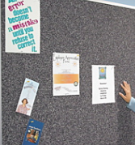 | $289.99 | 4
6 round tables on wheels in the open Whole Group Instructional Area.  http://www.demco.com/goto?BLS167954&ALL0000&es=20130423160817680895 | -Smith System Interchange Diamond Desk  -Top laminate color- Pewter Mesh  -Edge band color- Apple  -22”-34” x 34” x 30” | 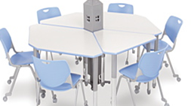 | $189.99 | 4 tables are needed to make one table.  4 x 6= 24
Rectangular tables with outlets in the closed off Instructional Room.  http://www.demco.com/goto?BLS173908&ALL0000&es=20130423161943037584 | -Balt Mobile Flipper Training Tables  -Tables can be configured in a variety of ways.  -Tables can fold for easy storage or removal for large group floor space  - 29” ½ H x 60”W x 24”D | 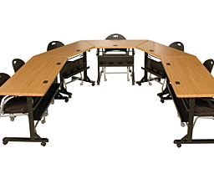 | $374.00 | 13
Chairs for all table settings. Chairs will be able to be stacked. (Approximately 75).  http://www.demco.com/goto?BLS167963&ALL0000&es=20130421170905482526 | -Smith System Flavor Chairs  -Yellow  -16”H |  | $83.99 | 75
Plush carpet for students to sit or read on. | (See Cozy Corner for details)
Window blinds  http://www.lowes.com/pd_185914-978-ERWCDD4207201D_4294856886__?productId=3393278&Ns=p_product_price|0 | -Custom Size Now by Levolor  - 42-in W x 72-in L  -White Wood  -2-in Slat Room | 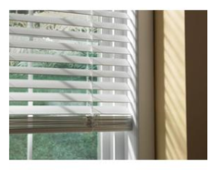 | $77.40 | 4

Area 4: Production and Group Project Area (Standard 6.01.04) (Maryland State Board of Education, 2000).
In this area there will be:
- A Professional Collection/ Collaborative Planning Room
  - This room will be used for collaborative planning, preparation of materials, and small group professional development meetings.
    - A large meeting table with outlets and comfortable rolling chairs.
    - A laptop station with an LCD projector so teachers can share information for presentations.
    - Professional Collection Materials will be housed here.
    - A bulletin board will be present to share professional development opportunities and resources.
- A Teacher Workroom
  - This room will be used for teachers to copy, create and prepare materials for classroom usage.
- As mentioned earlier, both the Closed Reference/Instructional Room and the Open Whole Group rooms can be used for meetings and student group work when not used for formal instruction. All tables and chairs can roll or be folded in order to maximize space.
- A TV Production Room
  - Students will use this room to produce the morning announcements. Some of the topics on the morning announcements may include lunch menu, upcoming events, schedule changes, club meetings, etc.
  - Classes may also use this space to develop video produced projects.
  - The equipment located in this room will include microphones, dvd player, mixer, tripods and cameras.

Usage | Specifications | Photo | Price | Quantity
A large meeting table with outlets  -Larger groups can use this for SST or IEP meetings  http://www.demco.com/goto?BLS192724&ALL0000&es=20130423163724764472 | -DEMCO Conference Tables  -Rectangular  -29 ½” x 96” x 48”  -Mocha Walnut | 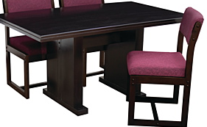 | $709.99 | 2
Comfortable chairs – 12 will be needed at the conference table listed above  http://www.demco.com/goto?BLS173963&ALL0000&es=20130423164623044945 | -SAFCO Flaunt Mobile Chair  -Will roll and swivel  -Adjustable seat  -Black Microfiber  -18”W x 17 ½” D | 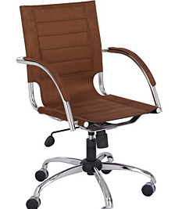 | $309.99 | 12
Bulletin board  http://www.demco.com/goto?BLS172151&ALL0000&es=20130421165717246287 | -Best Rite Rubber Tak Bulletin Boards  -Green  -4’H x 12’ W | 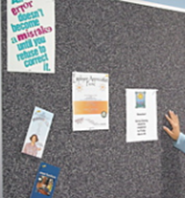 | $289.99 | 1
Cameras  -To be used for taping purposes in the TV Production Room  http://www.demco.com/goto?BLS175351&ALL0000&es=20130421150717054795 | -Hamilton Digital Video Camcorder Kit  -Contains 4 cameras  -Video, photo and MP3 capabilities  -Can be transferred to PC easily | 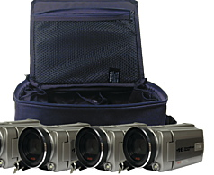 | $719.99 | 1
Tripods  -for used in the TV Production Room  http://www.demco.com/goto?BLS175364&ALL0000&es=20130421151025616327 | -Smith Victor Pinnacle Tripods | 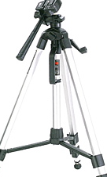 | $ 59. 29 | 2
Microphones  -for use in the TV Production Room  http://www.demco.com/goto?BLS175433&ALL0000&es=20130421151317523525 | -Hand held-wired microphones | 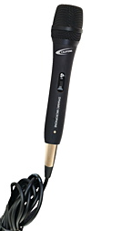 | $55.94 | 2
DVD player  -for use in the TV Production Room  http://www.demco.com/goto?BLS175332&ALL0000&es=20130421151510528826 | -Toshiba SD-4300 DVD Player  -Supports DVD-R, DVD-RW, DVD+R, DVD+RW, VCD, SVCD, CD-R, CD-RW, MP3 and WMA | 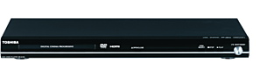 | $63.94 | 1
Mixer  -for use in the TV Production Room  http://www.bhphotovideo.com/bnh/controller/home?O=&sku=746667&is=REG&Q=&A=details | -Edirol / Roland VR-5 AV Mixer & Recorder | 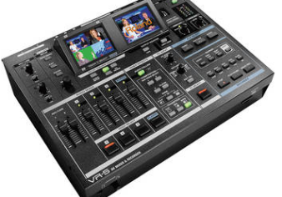 | $4995.00 | 1
Area 5: Administrative Area (Standard 6.01.05) (Maryland State Board of Education, 2000).
In this area there will be:
- A Circulation Desk.
  - This desk will be centrally located.
  - It will include a book drop, scanner, check out materials and storage under the desk.
  - Shelves will line the outside of the desk. These shelves will hold new book arrivals.
- An Administrative Office
  - The librarian will have a desk here as well as a place for support staff desk.
  - A small table and chairs will be located in this room so teachers can stop in to plan collaboratively with the librarian.
  - A large window will be located in this room so the librarian can keep a visual on activities going on in the library.
- A Storage Room
  - This room will be locked for librarian to keep track of materials being checked out or used in the library.
  - Three mobile laptop carts will be housed here for check out.
  - Extra supplies or support materials can be stored here.
  - Also, the network serves and technical equipment will be located in this room.

Usage | Specifications | Photo | Price | Quantity
Circulation desk  http://www.demco.com/goto?BLS174178&ALL0000&es=20130421172816583246 | -Paladin Arcadia Circulation Desk Corner Cabinets  -Light Oak base  -Rio Sands countertop  -30’W x 30”D  -Elementary height | 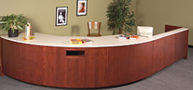 | $954.99 | 1
Book drop box | Already in circulation desk
Shelves for new  Books  http://www.demco.com/goto?BLS175552&ALL0000&es=20130423155014702449 | -Display shelf  -Ironwood Display Periodical Shelf  -1”x35”x13”  -Medium Oak and Brown | 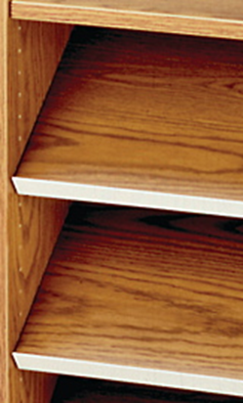 | $99.99 | 2
Librarian Desk and chair (will need two possibly for support staff)  http://www.demco.com/goto?blk00173893&intcmp=BMR_00173893 | -Steel Pedestal Desk  -L Shaped Desk Ped. Return  -29”x67”x37 4/5”  -Oak | 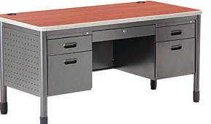 | $729.00 | 2
Small table and chair for planning  http://www.demco.com/goto?BLS194160&ALL0000&es=20130424185832813498 | -DEMCO table and chair set  -60”W x 36”D  -Leg base option  -Wood finish- Mocha Walnut  - Fabric- Navy | 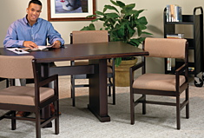 | $889.99 | 1
Mobile laptop carts | (See above)
Decorative lantern lights  http://www.walmart.com/ip/Thomas-Lighting-Silk-Shade/14555435 | -Thomas Lighting Silk Shade  -10”H x 5” W  -Color- Yucca | 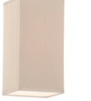 | $22.99 | 6

Section 4: Environmental Design Specifications

The environmental design will incorporate all areas of the Educational Specifications in order for the facility to work properly. This will also allow for productive use of the library. The following specifications are based on the West Towson Elementary Library standards. (Baltimore County Public Schools, n.d.).
Environmental Design Specifications based on the following website: Whole Building Design Guide found at http://www.wbdg.org/design/school_library.php.

- Structural- All areas
  - Ceiling Height- 9ft/ 4in for an open feeling.
    - Skylights can be added for more natural lighting (Whole Building Design Guide, 2011).
  - Large windows are found in the following areas:
    - Administrative Office so the librarian can be in touch with the activities taking place in the library at all times.
    - On both sides of the Circulation Desk so students are encouraged to enter the library.
    - There are windows on both sides of the SMART Board in the Whole Group Instructional Area.
  - Acoustics- All areas
    - Wall to wall carpeting and area rugs will cut down the echo effect.
    - Sound proof walls will allow many groups to function simultaneously and ensure the small work rooms enable independent work. Students should be able to hear instruction and not be distracted. (Whole Building Design Guide, 2011).
  - Finishes- All areas
    - Walls painted in yellow and green.
    - Mural with popular story characters near the Whole Group Instruction.
    - The library will feature various brown shades of finish.
  - Flooring:
    - Berber carpets will be installed though out the library so tables and chairs can be easily relocated.
    - Colorful carpets in Whole Group Instruction and Informal Reading Area (Cozy Corner). Rugs will provide worker comfort and increase productivity (Whole Building Design Guide, 2011).
  - Counter tops and flat surfaces are laminate to reduce damage and for easy clean up.
- Mechanical
  - Climate control will be controlled by school’s central office.
  - AC will be necessary so that computers do not overheat. This will increase AC loads.
  - Plumbing/Gas
    - A sink will be located in the Work Room for teacher use.
- Electrical
  - Electrical Outlets
    - In all rooms, each 8 feet there will be electrical outlets.
    - All tables will have power outlets.
    - A bench in the Informal Reading Area will have outlets as well.
    - Online stations will have outlets on them.
    - In all areas there should be wireless internet access.
    - Ceiling outlets are needed for any LCD projectors or SMART Boards.
    - Extra outlets should be installed in the Storage Room in order to charge and keep technology student ready. Internet servers will be housed in the Storage Room and will require extra outlet use as well.
According to Emerging Issues, there should be room for future cables and more networks. There will be plenty of room for expansion. Given that much of the access is wireless, there will be plenty of room for growth (Whole Building Design Guide, 2011).
  - Lighting
    - Recessed Florescent Lighting should be in all areas. These bulbs are 3-5 times as efficient and have the ability to be dimmed. (Whole Building Design Guide, 2011).
    - Hanging decorative light fixtures will be over top of the Circulation Desk.
    - Lamps and lanterns will be overhead of the Informal Reading Area.
    - In Collaborative Planning Room and the Closed Off Instructional Area, dimmers can be on lights for the ease of projections.
  - Security
    - The Storage Room and Administrative Room will be locked to secure materials.
    - A PA system and in/out of school phone lines.
    - The circulation desk and the OPAC will be used to keep track of who has signed out books and when those books are due to avoid stealing

Section 5: Accommodations for Learners with Special Needs (The Association of Specialized and Cooperative Library Agencies, 2013).
Accommodations for:
- Handicapped Students
  - Signage at eye level.
  - Signage is bright and colorful.
  - Tables and desks are accessible and chairs can be removed.
  - There will be 42inches between the stacks to accommodate those in wheel chairs. (The Magazine of American Library Association, 2013).
  - Shelving will be 3ft high or less for all patrons to access.
  - There are no check-out lanes and the circulation desk will be accessible to those in wheel chairs.
- Students who are deaf
  - The Virtual Learning Commons will aid students in accessing library materials and communicating with staff.
- Students with Autism or Learning Disabilities
  - Teachers will need to keep areas free from clutter and organized.
  - Use icons in signage to direct patrons.
  - Work areas can be private and quiet when needed.
  - Signage should be high contrast and bright/large print.
  - Steps to checking out materials can be displayed.
  - Audio book collections can be purchased.
- General Accommodations
  - A touch screen work station will be available for students to locate resources.
  - An adjustable computer workstation will be located on the end of the computer work stations.
  - Doors will include a push button to open and close feature.
  - Berber carpet will prevent tripping and slipping.
  - Reserve materials will be kept behind the Circulation Desk and given out as needed.

Usage | Specifications | Picture | Price | Quantity
Touch screen work station  http://www.demco.com/goto?BLS185763&ALL0000&es=20130423162652131155 | -TouchIT Fusion™ Interactive Touch Screens  -55” x 32” base with screen-tilt adjustable  -Compatible with software to accommodate all world-languages  -Single main power connection | 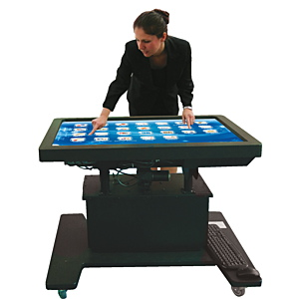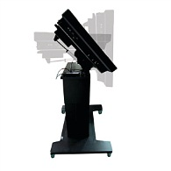 | $12,999.99 | 1
Adjustable computer work station  http://www.shopbrodart.com/furnishings/computer/ada-accessible/_/ADAS-Desks-with-Book-Storage/ | -ADAS Populas Desks with Book Storage  -19"W x 5"D comfort curve enhances accessibility  -Convenient book storage compartment (14"H x 7"W x 14"D) on the side to maximize knee space | 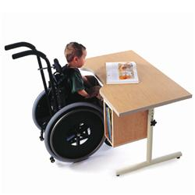 | $407.00 | 2
Doors with push button to open and close  http://www.disabilitysystems.com/switches/handicap-door-activation.html | -Activation Switch  - 4-1/2 inch square stainless steel handicap push plate switch.  -Can be used with CPTX wireless transmitters or hard wired. Includes faceplate, mounting plate and cherry micro switch. |  | $62.00 | 2 (for each door in the library

Section 6: Signage and Displays
- Signage will need to be located at:
  - Check out
  - Book return
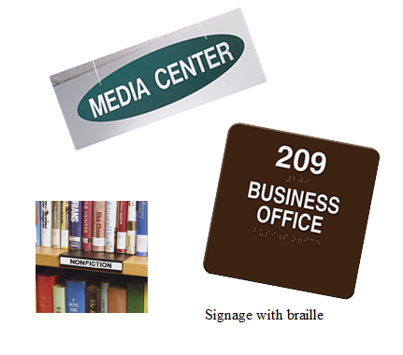
  - Tv Studio
  - Fiction
  - Non Fiction
  - Touch Screen Computer
  - Computer
  - Instructional Area
  - Collaborative Planning Room
  - Magazines
  - New Books
  - Teacher Workroom
  - Administrative Room
  - Storage Room
  - Everybody Books
  - Informal Reading Area (Cozy Corner)
- Signage should be in bold colors, high contrast, and located at eye level.
- Icons should be placed on the signage for each genre along with the Dewey Decimal Number.
- Braille should be on the ends of shelving units.
- Library Rules and Policies will be displayed behind the circulation desk.
- Student work will be displayed with the child’s name and grade on top of the fiction book section as well as in the closed off Instructional Area.
- Bulletin boards will be next to the SMART Board and will be displays of various types of genres and the elements of those kinds of materials.
- Search Strategies and Database tips will be located on the walls opposite the computer stations.
- Inspirational/ celebrity posters can be hung in the Cozy Corner or Informal Reading Area.
- Lexile stickers will be placed on the spine of each book. Students will be informed of the best reading materials for their level.

Section 7: Outcomes and Responsibilities
Item/ Space in the MC | Measurable Outcomes | Responsibilities of the SLMS
Display Shelves | Students will have their work displayed on the shelves in the library. It might also include projects from previous years, for example science projects, so students will get an idea of what their final project should look like and use the library for researching their topics. These displays will be motivating and informative. The SLMS can measure their learning by asking the students questions about what they have learned from some of the projects on display and how they could apply their learning to their everyday lives. | The SLMS should ensure that there is always a set of students’ work on display in the library. She should also circulate the project several times throughout the year so that all students have a chance to have their work displayed prominently in the library.
Instructional Area with Smart Board | In the Formal Instructional Area in the center of the library there will be a SmartBoard. This board will be used to engage and motivate the students in the lesson and use the many tools that are compatible with this device to teach students. The SLMS will be able to use anecdotal records to measure the student’s engagement with the SmartBoard and use assessments to determine if students are accomplishing the goals of the curriculum using this device as a learning tool. | The SLMS should ensure that she incorporates the use of this technology in her lessons to make them engaging and to introduce the students to different kinds of technology. The SLMS should also encourage the use of this technology to other staff members in the school and show them the benefits and the myriad of uses this technology has to offer.
Bulletin Board | This item will be used to post informative documents, brochures, newsletters, etc. for both students and faculty about new technologies, events, polices, etc. The SLMS can measure that this bulletin boards is being used by taking surveys to see if the information is useful and document any questions or concerns students or faculty may have about certain topics. | The SLMS should keep up-to-date on news and new technologies and frequently change out documents. She should also ensure that if teachers or students have requests, questions, and/ or concerns that she will respond in effectively and efficiently.

References
Baltimore County Public Library. (2013). Perry hall branch: Baltimore county public library. Retrieved from http://www.bcpl.info/hours-locations/perry-hall
Baltimore County Public School System. (n.d.). Library media center: Educational requirements. Retrieved from http://www.bcps.org/offices/lis/office/admin/libraryfacilitieselem.pdf
Marlborough Elementary (2012, December). Marlborough lc: A celebration! [video file]. Retrieved from http://www.youtube.com/watch?v=5kRkck9N2aQ&feature=player_embedded
Maryland State Board of Education. (2000). Standards for school library media programs in Maryland. Retrieved from http://www.marylandpublicschools.org/NR/rdonlyres/EC67FB12-FE6B-464A-A2AD-D0C6307773E3/13092/SLMStandards.pdf
The Association of Specialized and Cooperative Library Agencies. (2013). Library accessibility: What you need to know. Retrieved from http://www.ala.org/ascla/asclaprotools/accessibilitytipsheets
The Magazine of American Library Association. (2013). The ADA and libraries. Retrieved from http://americanlibrariesmagazine.org/ask-ala-librarian/ada-and-libraries
Towson University. (2011, August). About cook library. Retrieved from http://cooklibrary.towson.edu/aboutUs.cfm
Whole Building Design Guide. (2011, September). School library. Retrieved from http://www.wbdg.org/design/school_library.php
Online Furniture Resources
DEMCO Library Store
BRODART Library Store
THE LIBRARY STORE, INC.
http://www.disabilitysystems.com/switches/handicap-door-activation.html
http://www.shopbrodart.com/furnishings/computer/ada-accessible/_/ADAS-Desks-with-Book-Storage/
http://www.ikea.com/us/en/catalog/products/70203768/
http://lapdesk.com/lap-desk/cid-9
http://www.touchboards.com/smartboards/SMART_SB885ixe-SMP.html?Source=Google&gclid=CIKu77DS3LYCFaNhMgodERcAjQ
http://www.apple.com/education/labs
http://www.walmart.com/ip/Thomas-Lighting-Silk-Shade/14555435
http://www.bhphotovideo.com/bnh/controller/home?O=&sku=746667&is=REG&Q=&A=details
http://www.lowes.com/pd_185914-978-ERWCDD4207201D_4294856886__?productId=3393278&Ns=p_product_price|0

