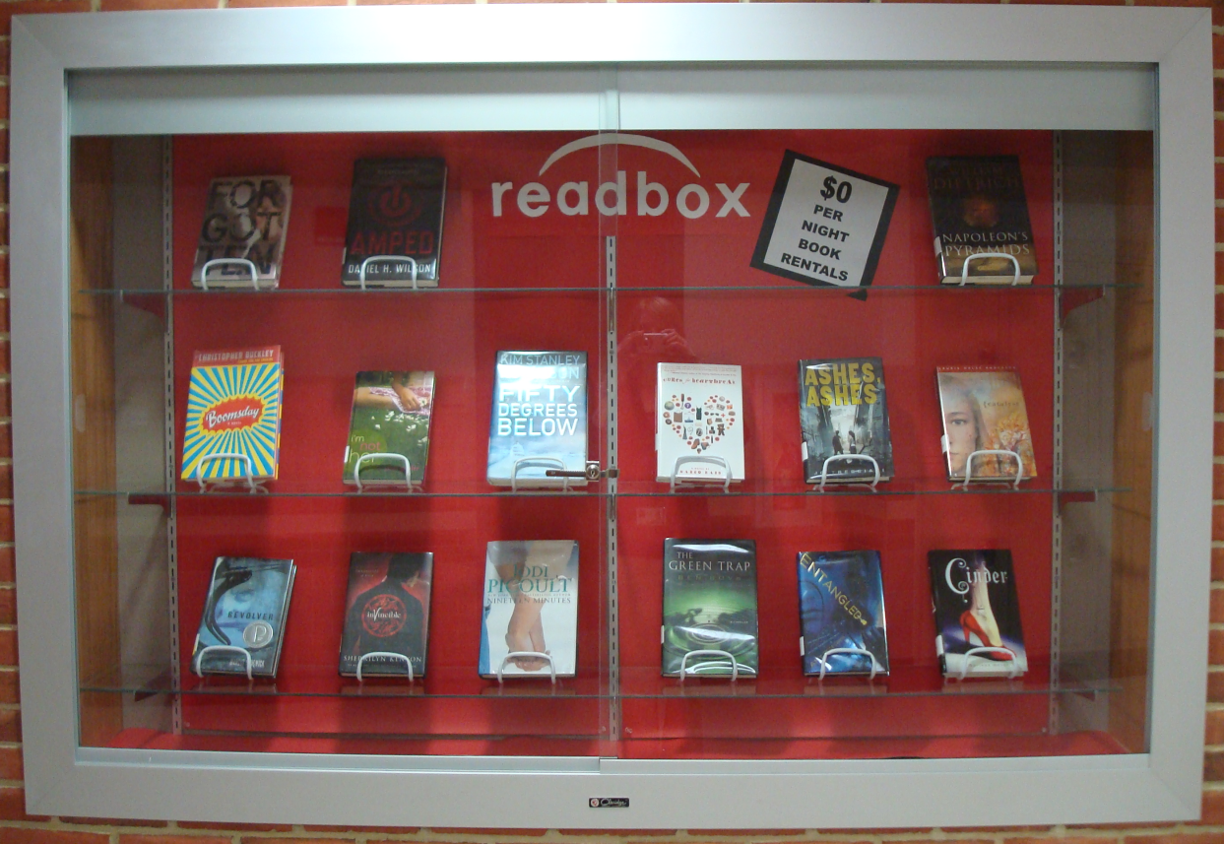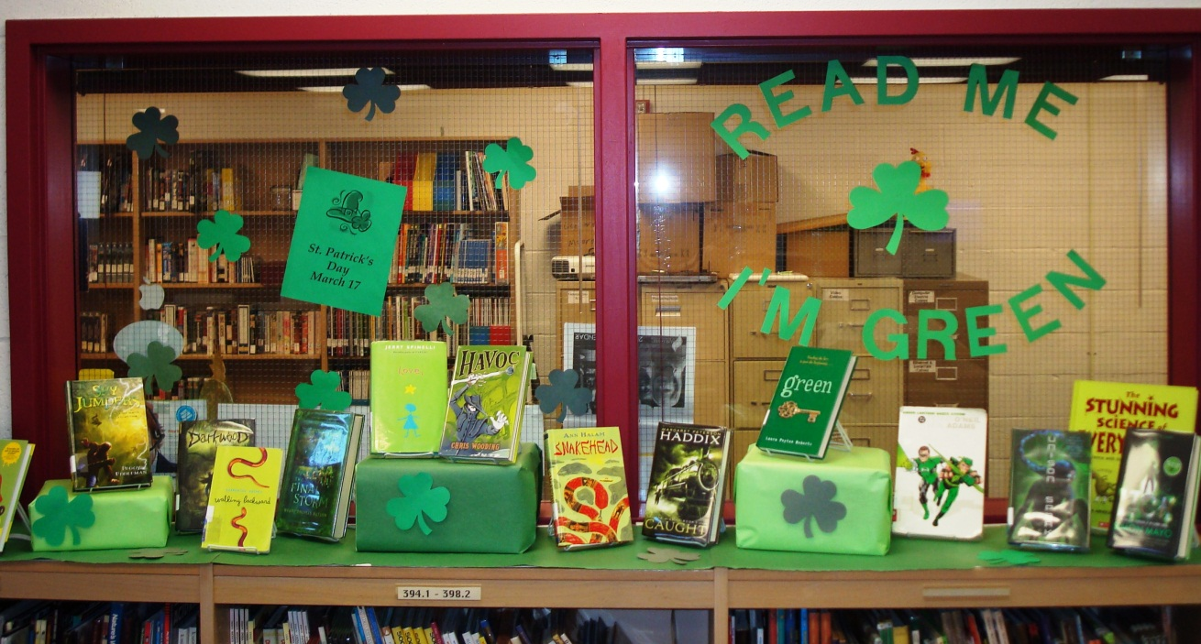

My St. Patrick’s Day book display, where all of the books on display have green covers.

My “readbox” display mimics the popular movie rental service redbox.

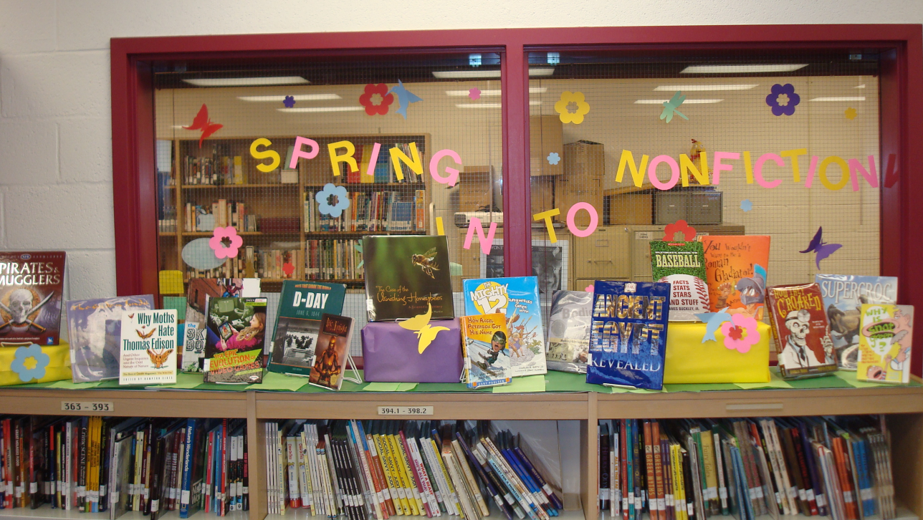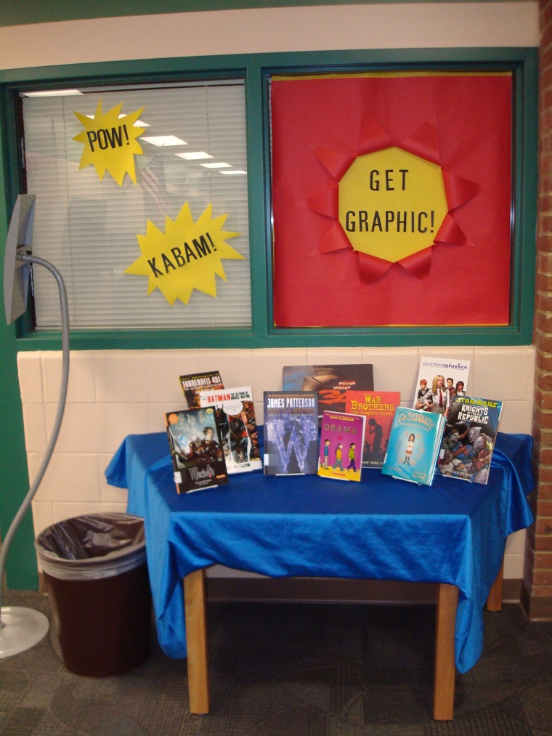

My spring book display, highlighting nonfiction books.

My graphic novel display at my high school placement.